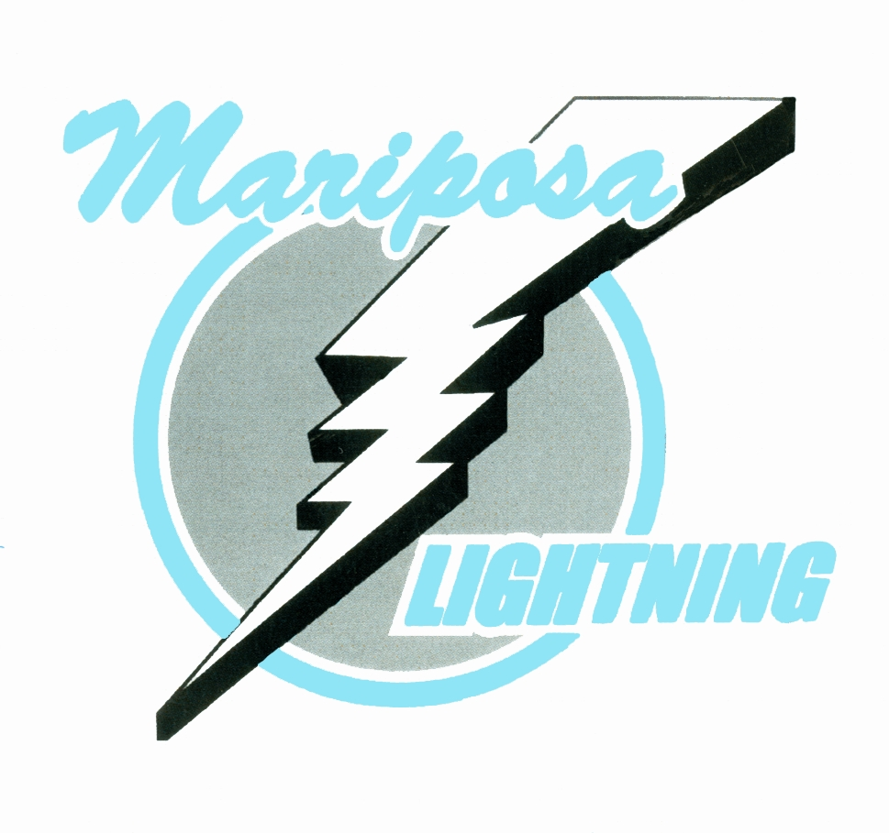MMHA Picture Day

Saturday October 5, 2018
Upstairs at Little Britain Community Centre

TIME DIVISION COACH

8:45 am Peewee TC Ken Fairman

9:15 am Atom AE Tom McMorrow

9:45 am Little Lighting Blue Kevin Walden

10:15 am Little Lighting Grey Bob Walden

10:45 am IP Blue Ange West

11:15 am IP Grey Trevor Short

11:45 pm IP Black Ryan Fox

12:15 pm Atom TC 1 Shawn Schreyer

12:45 pm Novice OMHA Colin Gibbs

1:15-2:00 pm Lunch
2:00 pm Minor Novice 1 Jeff West

2:30 pm Minor Novice 2

3:00 pm Atom OMHA Kris Boyd

3:30 pm Atom TC 2 Jeremey Farr/Jeff Wilson

4:00 pm Peewee OMHA Griffin Burke

4:30 pm Bantam OMHA Nick Roddy

5:00 pm Bantam TC Devin France

5:30 pm Midget TC Paul Bellefeuille

6:00 pm Midget OMHA Trevor Rogers

Please be dressed and ready 10 min before your time in full gear without Neck Guard, please carry skates, gloves, helmets and stick upstairs in Little Britain, and wear White home Jersey with Black Socks

